# 1.6.5: Finding Images

Google allows you to filter image results by the type of license.

1. Go to <https://images.google.com/?gws_rd=ssl> to search for an image.
2. Search for an image.
3. Find the Tools link and click it. It will open up a new menu bar of filtering choices.
4. Choose Usage Rights. It will give you two filtering options.  
   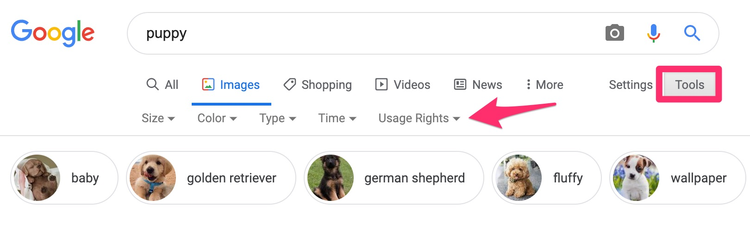

What do each of the options mean? You may need to research what each option entails.